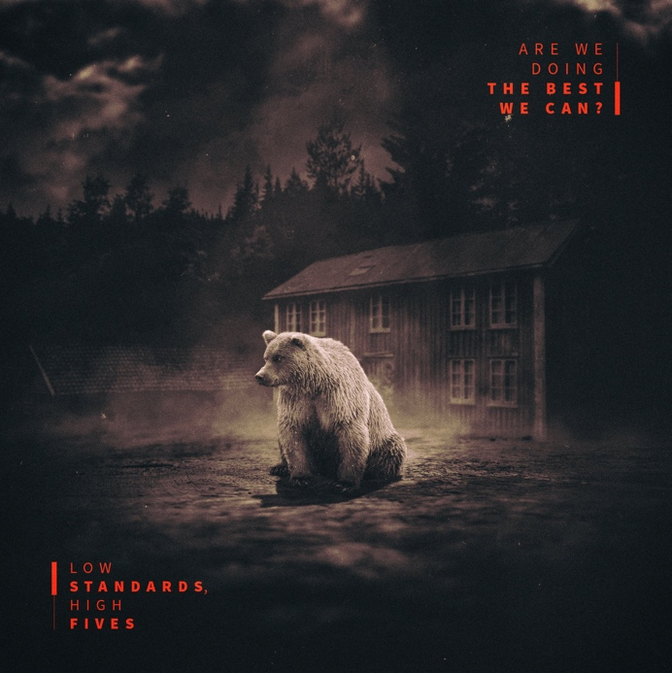

IGN244 LOW STANDARDS, HIGH FIVES – Are we doing the best we can? CD

LOW STANDARDS HIGH FIVES, a three-guitars indie rock band from Turin, Italy found inspiration for their latest album in the still vital catalogue of 90’s/00’s emo acts like Mineral, American Football, The Appleseed Cast, and The Promise Ring, and you can easily hear them kindle that same nostalgic feeling throughout. With “Are We Doing the Best We Can?” the quintet deliver a touching, subtle, yet dynamic and spirited work that will go down well with lovers of Sunny Day Real Estate, The Promise Ring, Braid, Penfold, American Football, Pop Unknown and The Appleseed Cast. The raucous post-punk guitar assaults are infused with an inescapable melodic sensibility.

Recorded live and mixed by Mànuel Volpe @ Spazio Rubedo in Torino, mastered by saffmastering.com in Chicago, “Are We Doing the Best We Can?” by LOW STANDARDS HIGH FIVES is out now on Engineer Records, Bandcamp, and Spotify.
Artwork by Carlo Di Stefano of wakeuproad.com.
LSHF Official Website lshf.it

1, Bite Me 03:32
2, Silent Decor 04:17
3, Night Seeds 02:19
4, The Twist 04:34
5, Remember Me 02:51
6, Just Like Silence 03:21
7, Slow Dancers In a Rush Hour 04:47
8, Crazy Boy 04:21
9, Distance By Connection 04:56

LSHF Video ‘Silent Decor’ https://youtu.be/1orenQ0ffy0
LSHF video ‘Bite me’ https://youtu.be/qMqJSQuyOsc
LSHF video ‘Slow dancers in a rush hour’ https://youtu.be/i1T4PPkV-bU

