NEW RELEASE ENGINEER RECORDS

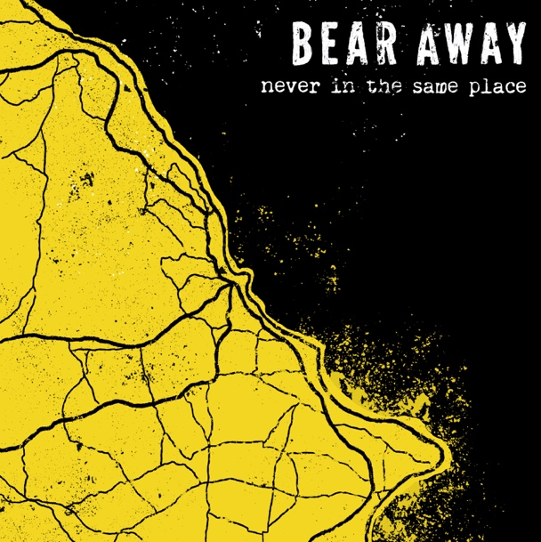

IGN261 BEAR AWAY – Never in the same place CD /cassette

Bear Away are a brand spanking new melodic punk rock band from Scarborough, UK.

Having formed in early 2019, five good friends and musicians from Yorkshire hardcore bands decided to make the music they all loved. With influences taken from Bouncing Souls and Hot Water Music, through to Menzingers and Iron Chic, they use these styles and add to them, creating their own catchy and powerful brand of melodic punk rock.

In July 2019 they released their first EP ‘Never in the same place’ on CD, cassette and digital with the help of Disillusioned Records and Engineer Records. This has been received very well, with positive feedback from people throughout the music scene, including the latest review from Razorcake magazine; “Strong and interesting twin guitar work plus a really good vocal performance go a long way to making Bear Away a band to keep an eye on".

The band is hard at work booking more shows and will be recording more music in the near future, but for now this is one hell of a debut release!

Find Bear Away on;
Instagram: instagram.com/bear.away
Facebook: facebook.com/bearawaymusic
Bandcamp: bearaway.bandcamp.com
Spotify: https://open.spotify.com/album/4I0Doz9sZ6UnATYaz6vLdM?si=RggP9T45QpemiWYCV5W_zA
Bandcamp: http://bearaway.bandcamp.com/album/never-in-the-same-place
Label: http://engineerrecords.com

Bear Away - Never in the same place CD tracklist:
1. Parts and labour
2. Is there any god up there
3. Growing up
4. Never complete

Bear Away is:
Jacob - Vocals
Oz - Guitar, Vocals
Dom - Guitar
Lewis – Bass
James - Drums

We can arrange interviews and send artwork, photos, logos, CDs, etc for reviews.

Thankyou for your support and keep on rocking.

David Gamage
http://engineerrecords.com

