NEW RELEASE ENGINEER RECORDS

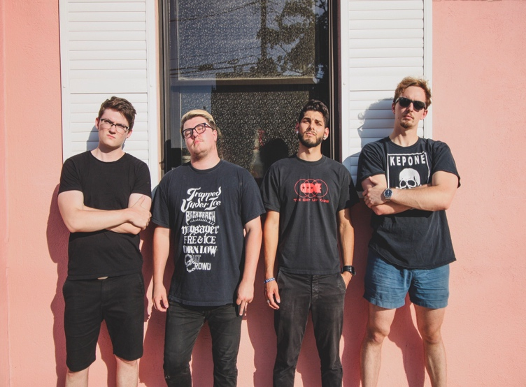

IGN273 SLEAVE – Don’t expect anything CD

"A set of vocals that pour out with emotions, guitars weep with melodies — Sleave know how to tie their emotions into their art. Blending multiple genres in their glimmer, the group infuses a weight into their music that lifts upon being heard. Sleave open the lid to a swirling catharsis of harsh vocals and swelling melodies."- New Noise Magazine

Richmond, VA's SLEAVE will release their upcoming debut album 'Don’t Expect Anything' on October 22 via UK indie label Engineer Records.
Sleave's sound brings together elements of alternative rock, punk, and American hardcore while also being reminiscent of the American grunge and emo movements of the 90's.
Three tracks and accompanying music videos are now streaming online
Music videos:
"Swept": http://bit.ly/2kobiCo
"Check Myself: http://bit.ly/2kGi9aF
"Homebound": http://bit.ly/2kpCjFx

Formed in Richmond, VA in 2016, Sleave began after Julien Robert and Charlie Bowen met at a party, where they quickly bonded over a shared interest in punk and alternative music. A series of impromptu jam sessions at Julien’s parent’s house during the fall of 2015 quickly turned into a full project. During this time, Sam Mclelland joined the band on bass and in January of 2016, Sleave officially formed.
The band’s presence grew steadily over the next two years, in which they debuted two releases (‘Gold EP 2016’ and Better Now/Empty Talk 7” 2017) and played countless shows in and around Richmond. The band then took a performing hiatus in 2018 to record what was rumored to be their first full-length album. The band worked tirelessly with the help of Pedro Aida of Audio Verite Studios and Andreas Magnusson, both of whom they had worked with on previous releases. During this time, Daniel Salinas replaced Sam Mclelland on bass; and the current Sleave lineup was formed.
Finally, in June 2019, Sleave announced their partnership with UK label Engineer Records, and that their first album was finally completed.
‘Don’t Expect Anything’ will be released under UK Engineer Records this October. https://www.facebook.com/sleaveofficial/
Sleave – Don’t expect anything CD tracklist:
1. All this time
2. Cataracts
3. Swept
4. Engine
5. Homebound
6. Check myself
7. Funeral
8. Better abettor
9. Charlton
10. Drinkin’
11. Sam’s song
12. Expect the world

Sleave are:
Charlie Bowen - Guitar and Vocals
Julien Robert - Drums and Vocals
Samuel McClelland - Bass
Daniel Salinas - Vocals

To request music, interviews, reviewers promo codes, photos, logos, additional information, etc please get in touch.

Thankyou for your support and keep on rocking.

David Gamage
http://engineerrecords.com

