NEW RELEASE ENGINEER RECORDS

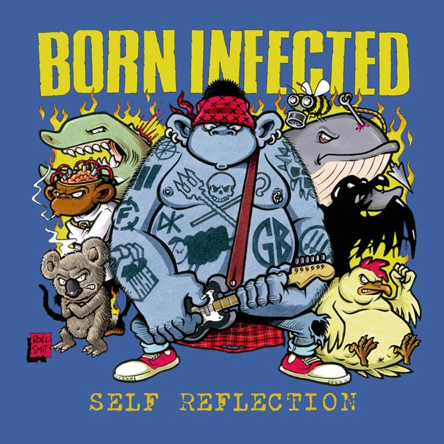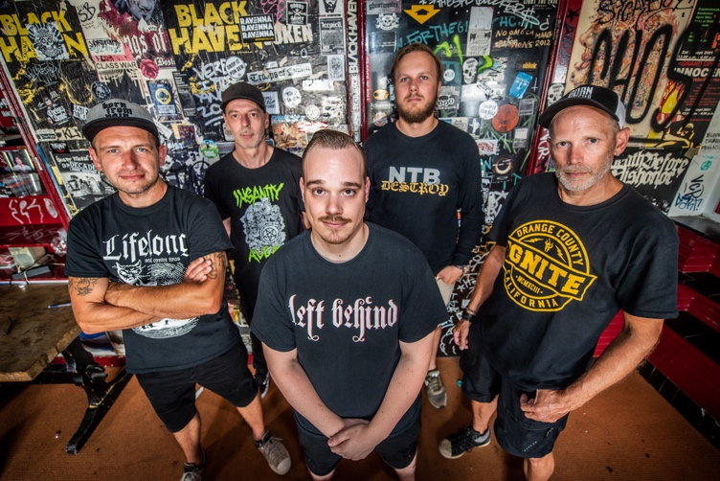

IGN305 BORN INFECTED – Self Reflection CD

BORN INFECTED is a new Dutch hardcore band founded in 2019. Ronald, Stan and Patrick already have a musical history together (Past our Means, Crawfish) but with the addition of Pascal (ex-Brickless, ex-Revealed) on bass and Ken (Reverse The Flow) on vocals, the band was complete.
The idea to make Born Infected a special project quickly arose. We all feel that our band and music should stand for something. Cooperation with other musicians and artists in the hardcore scene was a logical step to generate attention for organizations who need a platform and some extra support.

With the motto 'Stronger Together' we reached out to a couple of organisations/charities who we feel best embody our thoughts of what the hardcore scene should represent. Hardcore Help Foundation, Animal Rights and Sea Shepherd were enthusiastic immediately.

With our mix of hardcore, metal and punk we want to wake up the world a bit. Music is a big part of our life and a great way to express ourselves and demand attention for the things we think actually matter. https://www.born-infected.nl

The music video for ‘New Reality’ is now streaming online: https://youtu.be/yDGleiDCmsQ

To request music, interviews, reviewers promo codes, photos, logos, additional information, etc please get in touch.

http://engineerrecords.com

